STUDENTS PROJECT REPORT COVERAGE[V1.1]

The following sequence should be followed and maintained.
- Cover page, along with the title of the project and name of the candidate.
- Certificate obtained from industry (in case of the external project)
- Certificate obtained from guides ( in case of an internal project)
- Acknowledgment
- List of symbols, nomenclature, and abbreviations used
- List of Figures and Graphs
- List of Tables
- Abstract [ PURPOSE-METHODOLOGY-FINDINGS]
- Tables of Content
- Chapters organization
Chapter-1: Project description and outline
Chapter-2: Related work investigation
Chapter-3: Requirement Artifacts
Chapter-4: Design methodology and its novelty
Chapter-5: Technical Implementations and Analysis
Chapter-6: Project Outcome and Applicability
Chapter-7: Conclusions and Recommendation

References
Appendices (Additional Information if necessary).

[Report should be in A4 size paper with flexible cover]

AUTOMATED PATIENT AND DOCTOR DATA HANDLING SYSTEM
A PROJECT REPORT

Submitted by

Shringi Vyas (21BAI10414)
Vinamara Rawat (21BAI10181)
Mansi Kulshrestha (21BAI10249)
Mitali Irpatgire (21BAI10291)
Anurodh Pancholi (21BAI10396)

in partial fulfillment for the award of the degree
of

BACHELOR OF TECHNOLOGY

in
PROGRAM OF STUDY



SCHOOL OF COMPUTING SCIENCE AND ENGINEERING
VIT BHOPAL UNIVERSITY
KOTHRIKALAN, SEHORE
MADHYA PRADESH - 466114

February, 2023

VIT BHOPAL UNIVERSITY, KOTHRIKALAN, SEHORE
MADHYA PRADESH – 466114

BONAFIDE CERTIFICATE

Certified that this project report titled “AUTOMATED PATIENT AND DOCTOR DATA HANDLING SYSTEM ” is the bonafide work of “ Vinamara Rawat, Mansi Kulshrestha, Mitali Irpatgire, Anurodh Pancholi, Shringi Vyas” who carried out the project work under my supervision. Certified further that to the best of my knowledge the work reported at this time does not form part of any other project/research work based on which a degree or award was conferred on an earlier occasion on this or any other candidate.

PROGRAM CHAIR PROJECT GUIDE
Dr. S. Suthir Dr. Rudra Kalyan Nayak
Senior Assistant Professor Assistant Professor
School of Computer Science and Engineering School of Computer Science and Engineering
VIT BHOPAL UNIVERSITY VIT BHOPAL UNIVERSITY

The Project Exhibition II Examination is held on _______________

ACKNOWLEDGEMENT

First and foremost we would like to thank the Lord Almighty for His presence and immense blessings throughout the project work.
We wish to express my heartfelt gratitude to Dr. S. Suthir, Head of the Department, School of Computer Science and Engineering for much of his valuable support encouragement in carrying out this work.
I would like to thank my internal guide Dr. Rudra Kalyan Nayak,for continually guiding and actively participating in my project, giving valuable suggestions to complete the project work.
I would like to thank all the technical and teaching staff of the School of Aeronautical Science, who extended directly or indirectly all support.
Last, but not least, I am deeply indebted to my parents who have been the greatest support while I worked day and night for the project to make it a success.

LIST OF ABBREVATIONS

AI- Artificial Intelligence
ML- Machine Learning
EMR- Electronic Medical Record

ABSTRACT
The patient and doctor automated handling system website is a healthcare technology platform that seeks to streamline the patient experience and improve the efficiency of healthcare providers. The website provides patients and healthcare providers with a centralized location to manage patient information, schedule appointments, and communicate with each other.
The website uses artificial intelligence and machine learning algorithms to automate routine patient management tasks and assist doctors in providing better care. Patients can use the website to book appointments, update their personal and medical information, and access their medical records. The system provides an intuitive interface for patients to input their symptoms, and the AI algorithms provide recommendations based on the information provided.
The website also reduces the workload on healthcare providers by automating tasks such as appointment scheduling, patient check-in, and electronic medical record (EMR)updates. Healthcare providers can use the website to manage patient data, review medical histories, and communicate with patients securely.
The patient and doctor automated handling system website is a secure and reliable platform that is designed to comply with healthcare regulations and ensure patient privacy. By utilizing cutting-edge technology, the system provides patients and healthcare providers with a streamlined and efficient healthcare experience.

.

CHAPTER NO. | TITLE | PAGE NO.
 | List of Abbreviations  List of Figures and Graphs  List of Tables  Abstract | iii  iv  v  vi
1 | CHAPTER-1:  PROJECT DESCRIPTION AND OUTLINE  Introduction  1.2 Motivation for the work  1.3 [About Introduction to the project  including techniques]  1.5 Problem Statement  1.6 Objective of the work  1.7 Organization of the project  1.8 Summary
2 | CHAPTER-2:  RELATED WORK INVESTIGATION  2.1 Introduction  2.2 <Core area of the project>  2.3 Existing Approaches/Methods  2.3.1 Approaches/Methods -1  2.3.2 Approaches/Methods -2  2.3.3 Approaches/Methods -3  2.4 <Pros and cons of the stated Approaches/Methods >  2.5 Issues/observations from investigation  2.6 Summary
3 | CHAPTER-3:  REQUIREMENT ARTIFACTS  3.1 Introduction  3.2 Hardware and Software requirements  3.3 Specific Project requirements  3.3.1 Data requirement  3.3.2 Functions requirement  3.3.3 Performance and security requirement  3.3.4 Look and Feel Requirements  3.3.5 ………  3.4 Summary
4 | CHAPTER-4:  DESIGN METHODOLOGY AND ITS NOVELTY  4.1 Methodology and goal  4.2 Functional modules design and analysis  4.3 Software Architectural designs  4.4 Subsystem services  4.5 User Interface designs  4.5 ………………..  4.6 Summary
5 | CHAPTER-5:  TECHNICAL IMPLEMENTATION & ANALYSIS  5.1 Outline  5.2 Technical coding and code solutions  5.3 Working Layout of Forms  5.4 Prototype submission  5.5 Test and validation  5.6 Performance Analysis(Graphs/Charts)  5.7 Summary
6 | CHAPTER-6:  PROJECT OUTCOME AND APPLICABILITY  6.1 Outline  6.2 key implementations outlines of the System  6.3 Significant project outcomes  6.4 Project applicability on Real-world applications  6.4 Inference
7 | CHAPTER-7:  CONCLUSIONS AND RECOMMENDATION  7.1 Outline  7.2 Limitation/Constraints of the System  7.3 Future Enhancements  7.4 Inference

Appendix A

Appendix B

References

Note: List of References should be written as per IEEE/Springer reference format. (Specimen attached)

CHAPTER 1
PROJECT DESCRIPTION AND OUTLINE

  - Introduction
The project Automated Patient and Doctor Handling system includes the registration of patients, entering their details and symptoms into the system, and where the AI-ML predicted disorder will be displayed after which the same will be verified by the doctor along with the prescription. It allows patients to easily set up appointments. It is accessible by either the physician or the patient. Only. they can append data to the database. The data can be retrieved easily. The interface is very user-friendly. The data are well protected for personal use and make data processing very fast. The system is powerful, flexible, and easy to use and is designed and developed to deliver real conceivable benefits to hospitals. This system is designed for multispecialty hospitals, to cover a wide range of hospital administration and management processes. This is an end-to-end integrated hospital management system that provides relevant hospital-wide information to support effective decision-making for patient care and hospital administration in a seamless flow. It is a software suite designed to improve the quality and management of hospital management in the areas of clinical process analytics and business-by-business costing. This system enables you to develop your organization and improve its efficiency and the quality of its work and allows makes it easier for doctor to find the problem. The physician can easily have a look at patient's medical history.

  - Motivation for the work
The system will improve efficiency in patient registration, appointment management, and record-keeping. Doctors can access patients' medical history and view the ML-predicted problem based on their symptoms to provide appropriate treatment. The project's goal is to digitize patient and hospital information.
  - Introduction of project and techniques
There are two modules in the application - the admin module and the user module. With this application, the admin can not only preview monthly and yearly data but also edit, add, or update records. The admin can also manage and update information about doctors. The user module is accessible to both doctors and patients. The techniques used are HTML, CSS, JavaScript , Python and MySQL.
  - Problem statement
Waiting in long hospital queues can be time-consuming and frustrating, especially if the queuing process is managed manually by administrative staff. However, with the help of this system, patients can book their appointments online, check doctor availability, and even get automated predicted problem, doctor too gets easy access to patient’s medical history and prescribe accordingly. This system is crucial for all healthcare establishments, including hospitals, nursing homes, clinics, dispensaries, and rehabilitation centers. By automating patient and hospital-related information, it can improve administrative functions, ultimately resulting in better patient care, which is the primary goal of any healthcare unit.
  - Objectives of the Project
- Hospitals are institutions that provide medical treatment and care to patients.
- The staff and doctors have various responsibilities, such as recording patient information, diagnosis, and immunization records.
- They also keep track of different diseases and the available medicines to treat them.
- Previously, all these tasks were carried out manually on paper.
  - Summary
The Automated Patient and Doctor Handling system is a software designed to digitize patient and hospital information, improve efficiency in registration, appointment management, and record-keeping, and provide better patient care. The system includes two modules, admin and user, and utilizes HTML, CSS, JavaScript, Python, and MySQL. The system enables patients to book appointments online and allows doctors to easily access patient medical history and prescribe treatment. This system is crucial for all healthcare establishments.

CHAPTER 2
RELATED WORK INVESTIGATION

2.1 Introduction
In today's fast-paced world, waiting in long queues at hospitals can be a frustrating experience. The current system of manually managed queues, token distribution, and doctor appointments often leads to inconvenience and disappointment for patients. They may travel long distances only to find out that their desired doctor is unavailable or on leave.
This automated System can be a solution to these problems. It enables patients to book their appointments from the comfort of their homes and check the availability of their preferred doctor. The system can also predict the possible diseases based on the symptoms provided by the patients. Doctors can confirm or decline appointments, which helps both the patient and the doctor to save time and money. The doctor can access the patient's medical history and provide personalized care.
It is an essential tool for all healthcare establishments, including hospitals, nursing homes, health clinics, rehabilitation centres, dispensaries, and clinics. Its main goal is to computerize all patient and hospital-related information, leading to improved administrative functions and better patient care. This helps to achieve the primary focus of any healthcare unit, which is to provide the best possible care to patients.

2.2 Core area of the project
This system is intended to streamline various administration and management processes while being cost-effective. It offers secure data handling at every user-system interface and dependable storage facilities. The primary objective is to automate current systems efficiently.

2.3 Existing Approaches/Methods
Hospitals presently rely on a manual system to manage and maintain crucial information, which involves filling out numerous paper forms and storing data in various locations within the hospital's management infrastructure. However, this system has several drawbacks, such as incomplete or non-standardized data and lost forms in transit between departments. To prevent the loss of vital information, a thorough auditing process is necessary. Additionally, multiple copies of the same information exist in different data stores, which could result in inconsistencies in the data.

2.4 Pros and Cons of the stated Approaches/Methods
Pros of the existing Model:
- Less Maintenance.
- Provides patient with more privacy.
- No internet required.
Cons of the existing Model:
- Incomplete or non-standardized data and lost forms in transit between departments.
- To prevent the loss of vital information, a thorough auditing process is necessary.
- Additionally, multiple copies of the same information exist in different data stores, which could result in inconsistencies in the data.
- Access to patient’s medical history was a tedious task.
- Needs lot of paper work.

2.5 Issues/observations from investigation
- Data that is incomplete or not standardized, along with forms that get lost in transit between different departments, are some of the issues with the current manual system used by hospitals to manage critical information.
- To ensure that important information is not lost, it is essential to conduct a comprehensive auditing process.
- Having multiple copies of the same information stored in various data stores can lead to discrepancies in the data and may cause inconsistencies.
- Retrieving a patient's medical history was a laborious process.

2.6 Summary
An automated system can address the frustrations of patients waiting in long queues at hospitals. Patients can book appointments and check their preferred doctor's availability from home, saving time and money. Doctors can access patients' medical history. The system streamlines administrative and management processes, improving patient care and providing secure data handling. The goal is to automate current systems efficiently and cost-effectively. The system will also provide automated predicted medical disorder based upon the symptoms provided.

CHAPTER-3:
REQUIREMENT ARTIFACTS

3.1 Introduction
Hardware requirements are an essential set of specifications for any operating system or software application. To ensure compatibility, a hardware compatibility list (HCL) is often provided, which lists tested, compatible, and incompatible hardware devices. Software Requirements pertain to identifying the necessary software resources and prerequisites that must be present on a computer for an application to function optimally. These requirements are typically not included in the software installation package and must be installed separately before installing the software.

3.2 Hardware and Software requirements
- Operating System - Windows 7 or above/ Mac OS high sierra 10.13 or above
- Processor - Intel Pentium 4 or late or AMD 3020e
- Memory - 4GB minimum, 8GB preferred
- Hard Drive or SSD- Minimum 32GB, recommended 64GB or above
- Sound Card w/ Speaker
- Camera and Microphone.
- MySQL server
- Python and Django
- HTML
- Notepad ++ , CyberDuck

3.3 Specific Project requirements
3.3.1 Data requirement
In the event of a catastrophic failure that causes extensive damage to a significant portion of the database, the recovery process involves restoring a previous copy of the database from archived storage and reconstructing a more recent state by reapplying or redoing the operations of committed transactions from the backed-up log up to the time of failure. The database needed to complete this project was taken from Kaggle.
3.3.2 Functions requirement
The system is required to provide responses within 1 second of checking patient and other information. It should also be capable of supporting up to 1000 people at a time. The user interface should be responsive and provide screen updates within 5 seconds.
3.3.3 Performance and security requirement
The system requires unique logins for all administrative and data entry operators, ensuring that only authorized personnel can access the system. The system administrator is the only person with the authority to modify records and other critical data, and unauthorized access is not permitted.

3.4 Summary
Hardware requirements specify the necessary computer resources for an operating system or software application, and are accompanied by an HCL for compatibility. Software requirements identify necessary software resources and prerequisites, which must be installed separately for optimal application functioning.

CHAPTER-4:
DESIGN METHODOLOGY AND ITS NOVELTY

4.1 Methodology and goal
Methodology:
A skeleton was first prepared using HTML, the same was beautified with the use of CSS.
The inputs were taken in with the help of JavaScript. An AIML model based on Neural Network was built using Python dictionaries. The dataset was taken from Kaggle and was stored at MySQL server in the backend.
Goal:
  - User friendly
  - Simple fast
  - Low cost and effective
  - It deals with the collection of patient’s information
  - Automated Diagnosis
4.2 Functional modules design and analysis
It will have two main modules, one of the patient and other of the doctor, that of pharmacist can also be added.
User module(patient) allows to view the patient history, schedule the appointment with doctor, get predicted problem before consulting doctor, view prescription profile.
The Doctor module , provides prescriptions and medications, confirms the ML predicted problem and can see patient history.
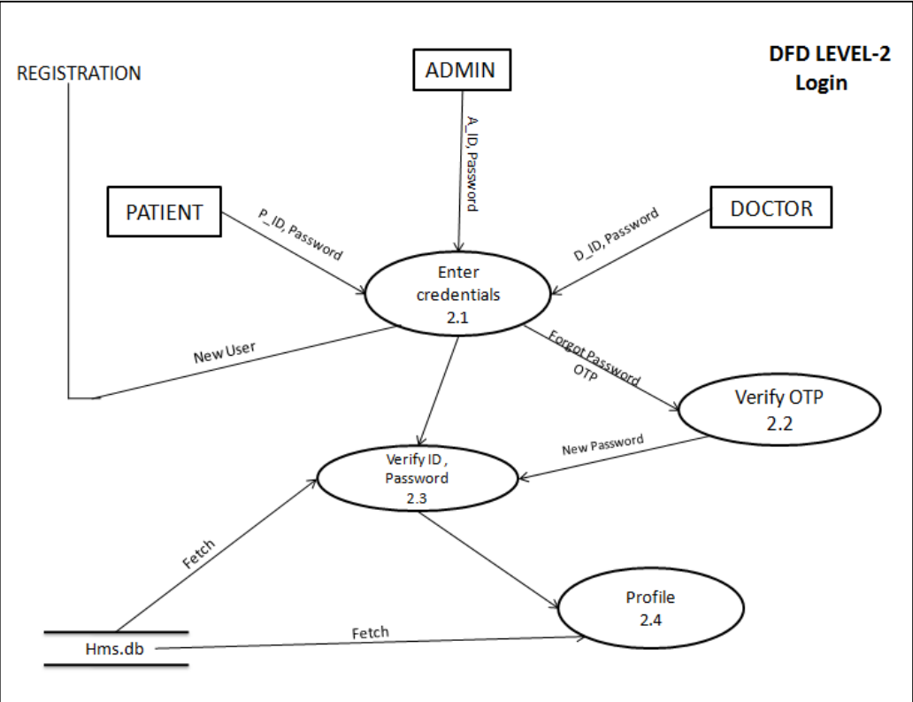
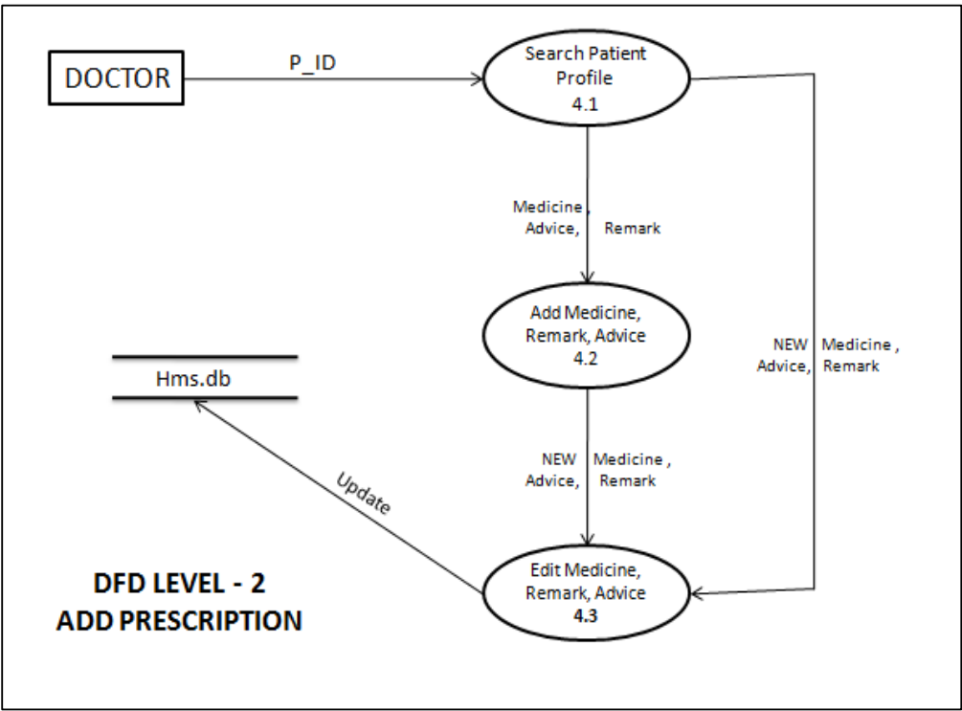

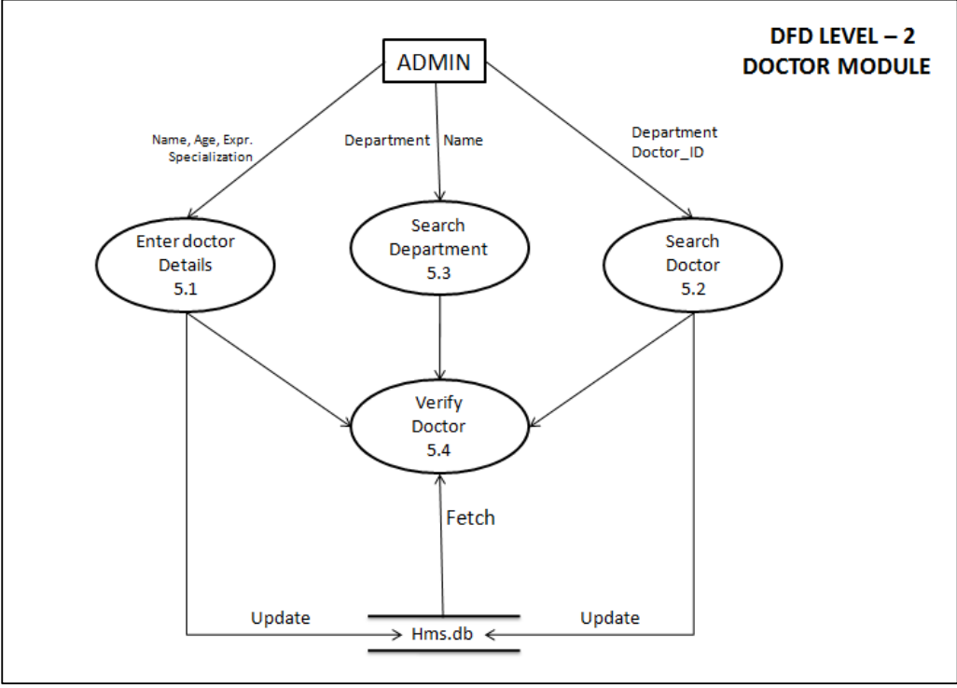
Data Design:
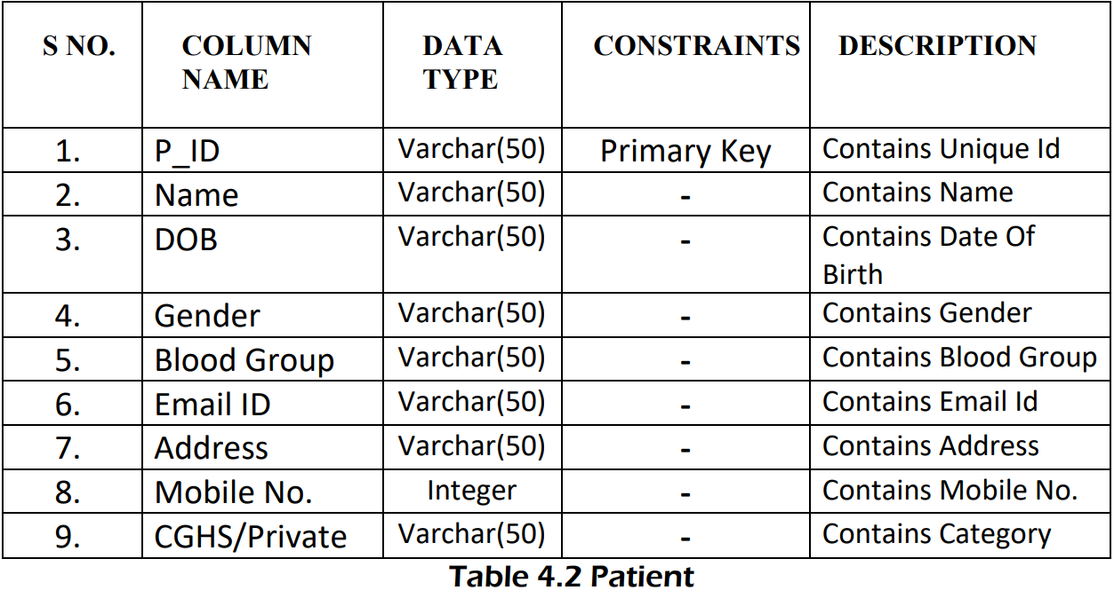
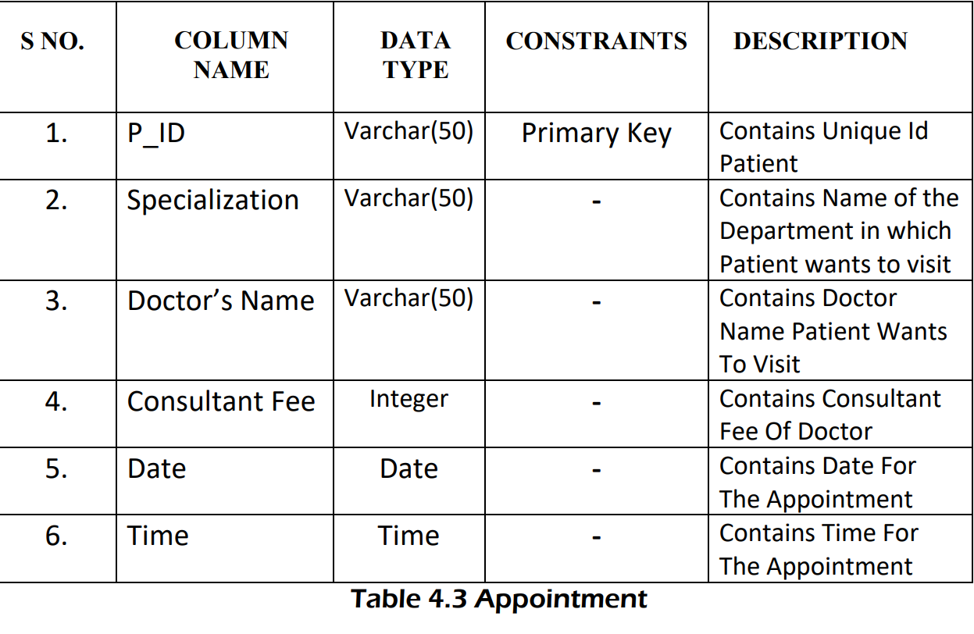
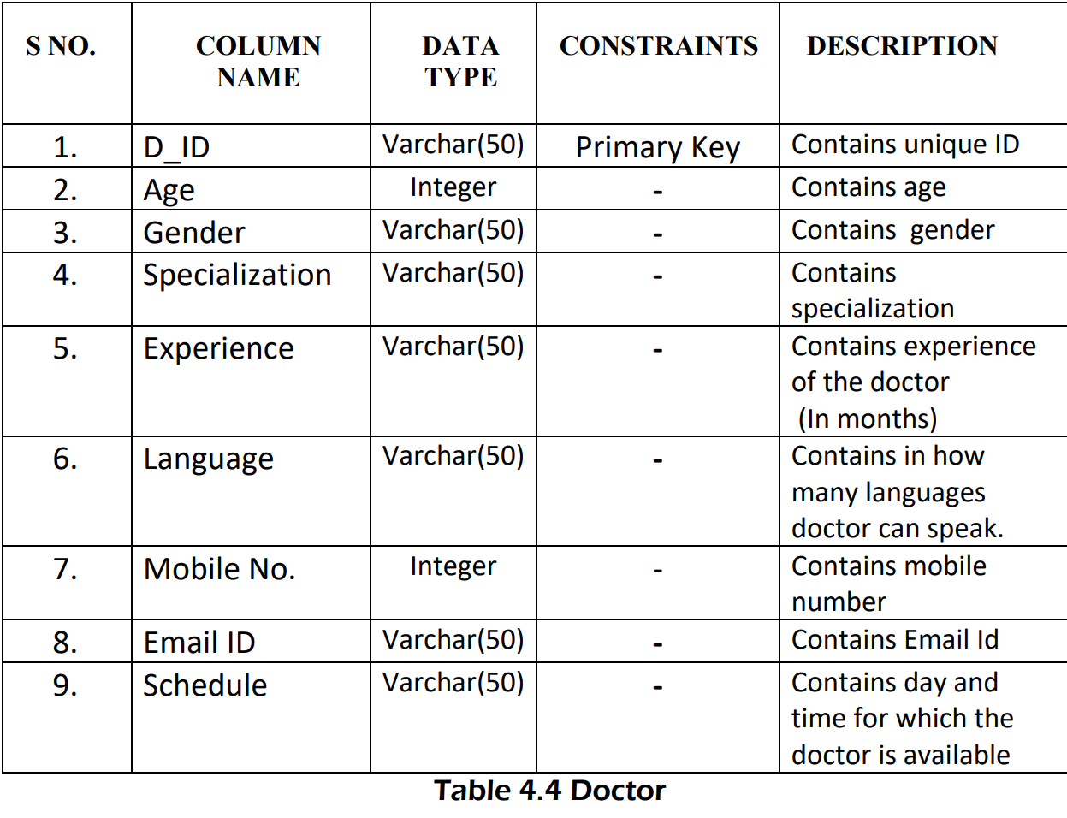
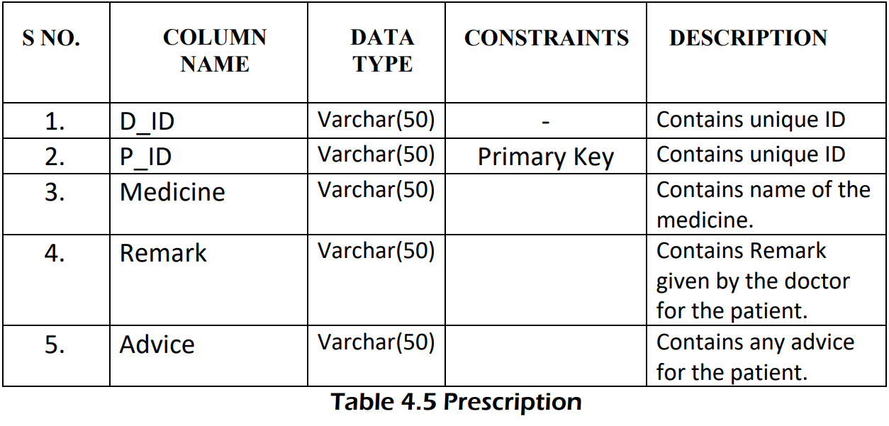

  - User Interface designs
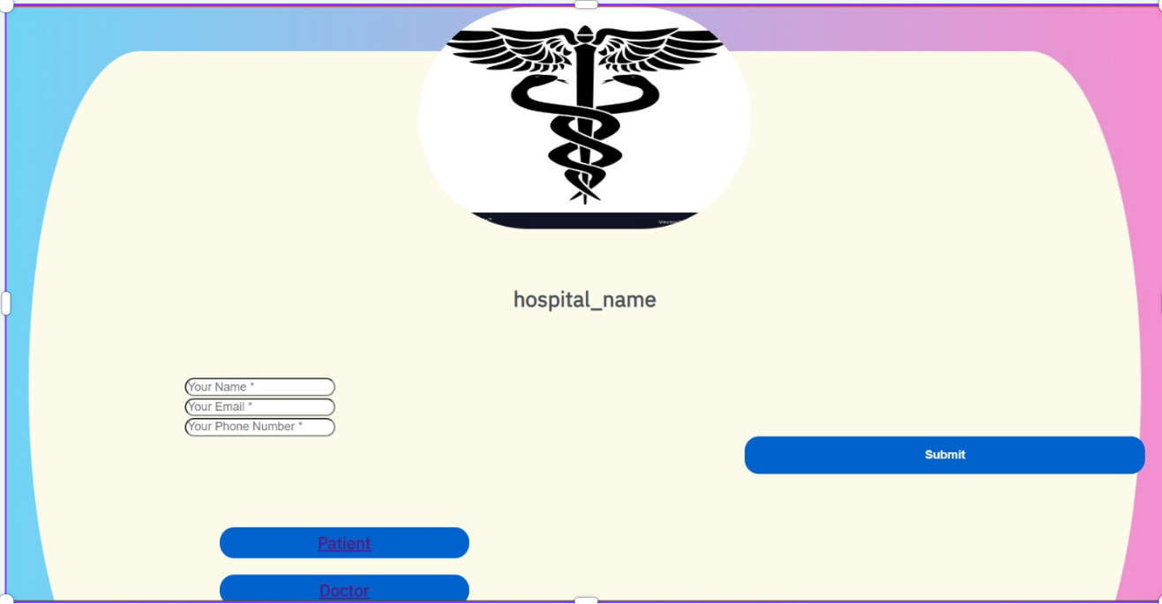
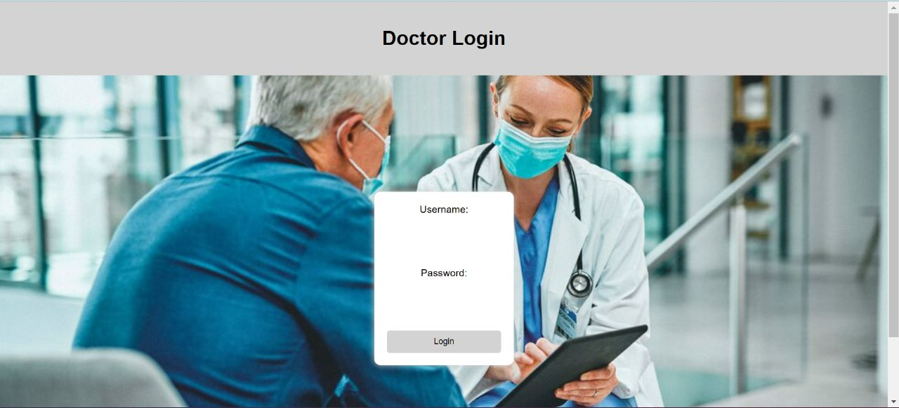
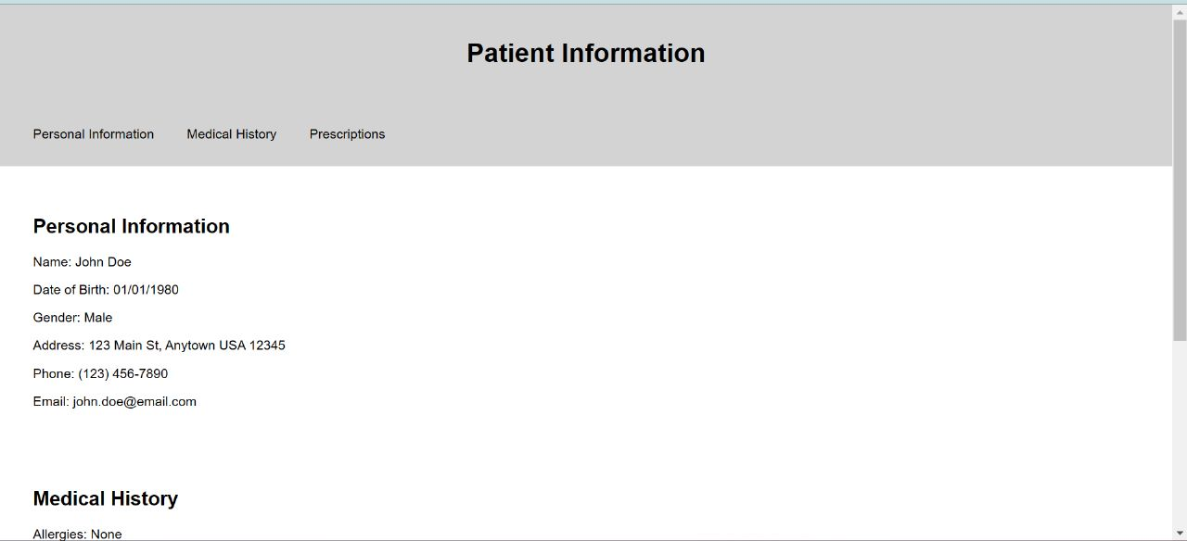
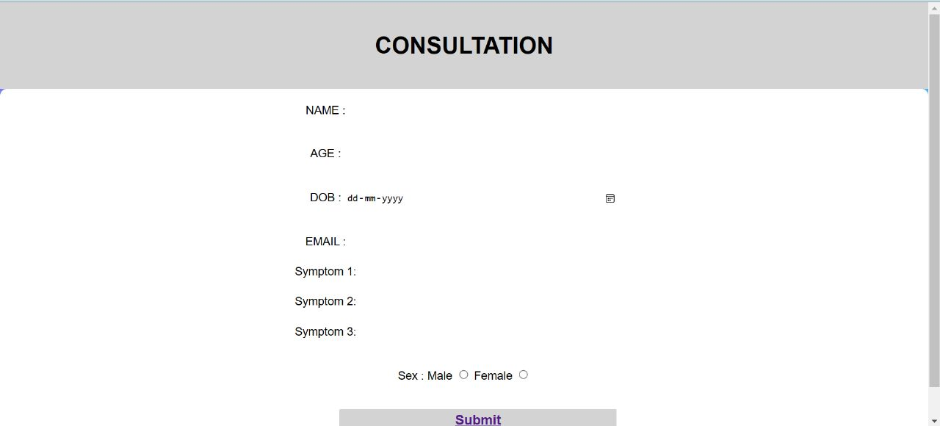
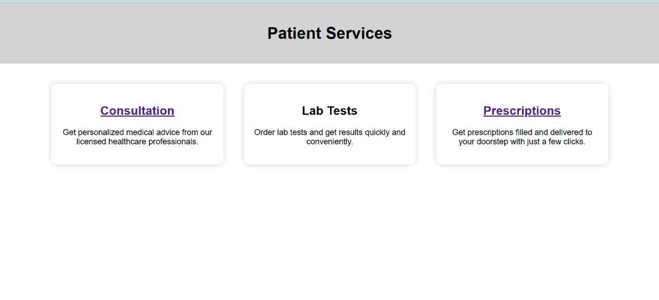

4.4 Summary
This project involved building a website with HTML, CSS, and JavaScript. An AIML model based on a neural network was created using Python dictionaries and a Kaggle dataset, and stored in a MySQL backend. The website aims to be user-friendly, fast, low-cost, and effective for collecting patient information and providing automated diagnosis. It has two main modules for patients and doctors, and a pharmacist module can be added. The patient module allows viewing of patient history, scheduling appointments with doctors, and receiving predicted problem diagnoses. The doctor module allows for prescribing medications, confirming diagnoses, and viewing patient history.

CHAPTER-5:
TECHNICAL IMPLEMENTATIONS AND ANALYSIS

5.1 OUTLINE
Technical implementation and analysis involve designing, developing, and deploying a technological solution. This phase includes coding, testing, and debugging, integrating the solution with other systems, configuring the software, and deploying it to the intended environment. The technical analysis evaluates the feasibility and limitations of the project, identifies potential technical risks, and helps select the best technologies and tools. By addressing technical issues early, the team can minimize risks and ensure the timely, efficient delivery of a high-quality solution.

  - TECHNICAL CODING AND CODE SOLUTION
Consulation.html :

<!DOCTYPE html>
<html lang="en">
<head>
<title>Patient page</title>
<link rel="stylesheet" href ="consultation.css">
<script src="consultation.js"></script>
<meta charset="UTF-8">
<meta http-equiv="X-UA-Compatible" content="IE=edge">
<meta name="viewport" content="width=device-width, initial-scale=1.0">

<style>
body {
background-image: url('consultation_bg.jpg');
background-size: cover;
}
</style>
</head>
<body>
<header>
<h1> CONSULTATION </h1>
</header>
<form action="backend.php">
<div>

</div>
<div>
NAME : <input type="text" name="Patients_name">
</div>
<br>
<div>
AGE : <input type="number" name="patients_age">
</div>
<br>
<div>
DOB : <input type="date" name="Patients_dob">
</div>
<br>
<div>
EMAIL : <input type="email" name="Patients_email" id="email">
</div>

<div>
Sex : Male <input type="radio" name="Sex" id="gnederM"> Female <input type="radio" name="Sex" id="genderF">
</div>
<br>

<form>
<label for="symp1"> Symptom 1: </label>
<select id="symp1" style="display: inline-block;">
<option value="itching">Itching </option>
<option value="shivering">Shivering </option>
<option value="stomach_pain">stomach pain </option>
<option value="headache">headache </option>
<option value="indigestion">Indigestion </option>
<option value="throat_patches">Throat patches </option>
<option value="fatigue">Fatigue </option>
<option value="sunken_eyes">Sunken eyes </option>
<option value="cough">cough </option>
</select>

<br>

<label for="symp2"> Symptom 2: </label>
<select id="symp2" style="display: inline-block;">
<option value="skin_rash">skin rash</option>
<option value="chills">chills</option>
<option value="acidity">acidity</option>
<option value="vomitting">vomitting</option>
<option value="chest_pain">chest pain</option>
<option value="loss_of_appetite">loss of appetite</option>
<option value="high_fever">high fever</option>
<option value="weight_loss">weight loss</option>
<option value="dehydration">dehydration</option>
</select> <br>

<label for="symp3">Symptom 3: </label>
<select id="symp3" style="display: inline-block;">
<option value="nodal_skin_eruption">nodal skin eruptions </option>
<option value="watery_eyes">watery eyes</option>
<option value="ulcers_on_tongue">ulcers on tongue</option>
<option value="nausea">nausea</option>
<option value="dizziness">dizziness</option>
<option value="abdominal_pain">abdominal pain</option>
<option value="restlessness">restlessness</option>
<option value="diarrhoea">diarrhoea</option>
<option value="breathlessness">breathlessness</option>
</select> <br>
<button type="button" onclick="document.getElementById('prediction').innerHTML = predict_Disease()">Predict Disease</button>
<p id="prediction"></p>
</form>

</form>
</body>
</html>

Consultation.css:
body {
font-family: Arial, sans-serif;
margin: 0;
}

header {
background-color: rgb(226, 223, 223);
padding: 20px;
text-align: center;
}

main {
display: flex;
justify-content: center;
align-items: center;
height: 100vh;
}

form {
background-color: rgb(225, 230, 233);
margin-left: 400px ;
margin-right: 350px;
padding: 20px;
border-radius: 80px;
box-shadow: 0 0 10px lightgray;
text-align: center;
}

label {
display: block;
margin-bottom: 2px;
}

input[type="text"], input[type="number"], input[type="date"], input[type="email"] {
width: 30%;
padding: 5px;
margin-bottom: 20px;
border-radius: 5px;
border: none;
}

label {
display: inline-block;
width: 90px;
/* optional: set the width of the label if needed */
}

select {
display: inline-block;
width: 30%;
padding: 5px;
margin-bottom: 20px;
border-radius: 5px;
border: none;
font-size: medium;
font-family: 'Times New Roman', Times, serif;
}

button{
display: inline-block;
width: 40%;
padding: 5px;
margin-bottom: 20px;
border-radius: 5px;
border: none;
font-size: medium;
font-family: 'Times New Roman', Times, serif;
}
option{
width: 40%;
padding: 7px;
background-color: rgb(239, 245, 249);
border-radius: 2px;
border: none;
cursor: pointer;
text-align: center;
}

Consultation.js
function predict_Disease() {
const symp1 = document.getElementById("symp1").value;
const symp2 = document.getElementById("symp2").value;
const symp3 = document.getElementById("symp3").value;

if (symp1 === "itching" && symp2 === "skin_rash" && symp3==="nodal_skin_eruption") {
return "You are likely to have fungal infection.";
} else if (symp1 === "shivering" && symp2 === "chills" && symp3==="watery_eyes") {
return "You are likely to have an allergy.";
} else if(symp1 ==="stomcah_pain" && symp2==="acidity" && symp3==="ulcers_on_tongue"){
return " You are likely to have GRED";
} else if(symp1=="itching" && symp2=="vomitting" && symp3=="nausea"){
return "You are likely to have Chronic cholestasis";
} else if(symp1=="headache" && symp2=="chest_pain" && symp3=="dizziness"){
return "You are likely to have Hypertension";
} else if(symp1=="indigestion" && symp2=="loss_of_appetite" && symp3 == "abdominal_pain"){
return "You are likely to have Peptic ulcer disease";
} else if( symp1=="throat_patches" && symp2=="high_fever" && symp3=="restlessness"){
return "You are likely to have AIDS";
} else if(symp1=="fatigue" && symp2=="weight_loss" && symp3=="restlessness"){
return "You are likely to have diabetes";
} else if (symp1=="sunken_eyes" && symp2=="dehydration" && symp3=="diarrhoea"){
return "You are likely to have Gastroenteritis";
} else if (symp1=="cough" && symp2=="high_fever" && symp3=="breathlessness"){
return "You are likely to have Bronchial asthma";
}

else {
return "We were unable to determine your illness.";
}
}
Login.html:
<!DOCTYPE html>
<html>
<head>
<title>Doctor Login</title>
<link rel="stylesheet" type="text/css" href="d_login.css">
</head>
<style>
body {
background-image: url('patient_bg.jpeg');
background-size: cover;
}
</style>
<body>
<header>
<h1>Doctor Login</h1>
</header>
<main>
<form action="#" method="post">
<label for="username">Username:</label>
<input type="text" id="username" name="username" required>
<br><br>
<label for="password">Password:</label>
<input type="password" id="password" name="password" required>
<br><br>
<input type="submit" value="Login">
</form>
</main>
</body>
</html>

Login.css:
body {
font-family: Arial, sans-serif;
margin: 0;
}

header {
background-color: lightgray;
padding: 20px;
text-align: center;
}

main {
display: flex;
justify-content: center;
align-items: center;
height: 100vh;
}

form {
background-color: white;
padding: 20px;
border-radius: 10px;
box-shadow: 0 0 10px lightgray;
text-align: center;
}

label {
display: block;
margin-bottom: 10px;
}

input[type="text"], input[type="password"] {
width: 100%;
padding: 10px;
margin-bottom: 20px;
border-radius: 5px;
border: none;
}

input[type="submit"] {
width: 100%;
padding: 10px;
background-color: lightgray;
border-radius: 5px;
border: none;
cursor: pointer;
}

Doctor appointment. Html
<!DOCTYPE html>
<html lang="en">
<head>
appointment
</head>
</html>
C++ Code:
#include <iostream>
#include <vector>

void merge(std::vector<int>& arr, int left, int mid, int right) {
int i, j, k;
int n1 = mid - left + 1;
int n2 = right - mid;

std::vector<int> L(n1), R(n2);

for (i = 0; i < n1; i++) {
L[i] = arr[left + i];
}
for (j = 0; j < n2; j++) {
R[j] = arr[mid + 1 + j];
}

i = j = 0;
k = left;
while (i < n1 && j < n2) {
if (L[i] <= R[j]) {
arr[k] = L[i];
i++;
} else {
arr[k] = R[j];
j++;
}
k++;
}

while (i < n1) {
arr[k] = L[i];
i++;
k++;
}

while (j < n2) {
arr[k] = R[j];
j++;
k++;
}
}

void merge_sort(std::vector<int>& arr, int left, int right) {
if (left < right) {
int mid = (left + right) / 2;

merge_sort(arr, left, mid);
merge_sort(arr, mid + 1, right);

merge(arr, left, mid, right);
}
}

int main() {
std::vector<int> arr = {38, 27, 43, 3, 9, 82, 10};

merge_sort(arr, 0, arr.size() - 1);

for (int i = 0; i < arr.size(); i++) {
std::cout << arr[i] << " ";
}

return 0;
}

Landing page. Html:
<!DOCTYPE html>
<html>
<head>
<title>Landing Page</title>
<link rel="shortcut icon" type="image/x-icon" href="images/favicon.png" />
<link href="//vitbhopalacin.sharepoint.com///maxcdn.bootstrapcdn.com/bootstrap/4.1.1/css/bootstrap.min.css" rel="stylesheet" id="bootstrap-css">
<link rel="stylesheet" href="vendor/fontawesome/css/font-awesome.min.css">
<link href="https://fonts.googleapis.com/css?family=IBM+Plex+Sans&display=swap" rel="stylesheet">
<link rel="stylesheet" type="text/css" href="landing_pg.css">
<script src="//vitbhopalacin.sharepoint.com///maxcdn.bootstrapcdn.com/bootstrap/4.1.1/js/bootstrap.min.js"></script>
<script src="//vitbhopalacin.sharepoint.com///cdnjs.cloudflare.com/ajax/libs/jquery/3.2.1/jquery.min.js"></script>

<script >
function alphaOnly(event) {
var key = event.keyCode;
return ((key >= 65 && key <= 90) || key == 8 || key == 32);
};
</script>

<style >
body{
background: -webkit-linear-gradient(left, #6cd6f7, #fa8dce);
}

.contact-form {
background: #fcfae9;
border-top-left-radius: 10% 50%;
border-bottom-left-radius: 10% 50%;
border-top-right-radius: 10% 50%;
border-bottom-right-radius: 10% 50%;
}

</style>
</head>
<body>
<nav class="navbar navbar-expand-lg navbar-dark fixed-top" id="mainNav" >
<div class="container">

</div>
</div>
</nav>

<div class="container contact-form" style="font-family: 'IBM Plex Sans', sans-serif;">
<div class="contact-image">
<img src="file:///C:/Users/vineet/OneDrive/Documents/GitHub/Hospital-Management-System/Project_exh/hospi_logo.jpg" width = "250" height="250" />
</div>
<form method="post" action="contact.php">
<h2>hospital_name</h2>
<div class="row">
<div class="col-md-6">
<div class="form-group">
<input type="text" name="txtName" class="form-control" placeholder="Your Name *" value="" onkeydown="return alphaOnly(event);" required/>
</div>
<div class="form-group">
<input type="email" name="txtEmail" class="form-control" placeholder="Your Email *" value="" required />
</div>
<div class="form-group">
<input type="tel" name="txtPhone" class="form-control" placeholder="Your Phone Number *" value="" minlength="10" maxlength="10" required />
</div>
<div class="form-group" >
<input type="submit" name="btnSubmit" class="btnContact" value="Submit" />
</div>
<br> <br>
<div>
<h3>
<a href="patient_pg.html">Patient</a></h3>

<header>
<h3><a href="d_login.html">Doctor</a></h3>
</header>

</div>
</div>

</div>
</form>
</div>

</body>
</html>

Landingpage.css:
body{
background: -webkit-linear-gradient(left, #3931af, #00c6ff);
align-items: center;
}

html {
overflow-y: scroll;
}

.contact-form{
background: #fff;
margin-top: 10%;
margin-bottom: 5%;
margin-left: 5%;
width: 90%;
align-self: center;
}
.contact-form .form-control{
border-radius:1rem;
}
.contact-image{
text-align: center;
}
.contact-image img{
border-radius: 10rem;
width: 30%;
margin-top: -4%;

}
.contact-form form{
padding: 14%;
}
.contact-form form .row{
margin-bottom: -7%;
}
.contact-form h2{
margin-bottom: 8%;
margin-top: -13%;
text-align: center;
color: #495057;
}

.contact-form .btnContact {
width: 50%;
border: none;
border-radius: 1rem;
padding: 1.5%;
background: #0062cc;
font-weight: 600;
color: #fff;
cursor: pointer;

}
.btnContactSubmit
{
width: 30%;
border-radius: 1rem;
padding: 1.5%;
color: #fff;
background-color: #0062cc;
border: none;
cursor: pointer;
}

.btnContact{

margin-left: 70%;
}

.contact-form .btnNavigation {
width: 20%;
border: none;
border-radius: 1rem;
padding: 2.5%;
background: #0062cc;
font-weight: 600;
color: #fff;
cursor: pointer;

}
h3{
width: 30%;
padding: 5px;
background-color: #0062cc;
color: #fff;
border-radius: 1rem;
border: none;
cursor: pointer;
text-align: center;
margin-left: 40px;
}
header.h3{
width: 30%;
height: 10%;
padding: 5px;
background-color: #0062cc;
color: #fff;
border-radius: 1rem;
border: none;
cursor: pointer;
text-align: center;
margin-left: 600px;
margin-top: -55px;
}

.btnNavigation{

margin-left: 2%;
}

Patient info.html:
<!DOCTYPE html>
<html>
<head>
<title>Patient Information</title>
<link rel="stylesheet" type="text/css" href="p_info.css">
</head>
<body>
<header>
<h1>Patient Information</h1>
</header>
<nav>
<ul>
<li><a href="#personal-info">Personal Information</a></li>
<li><a href="#medical-history">Medical History</a></li>
<li><a href="#prescriptions">Prescriptions</a></li>
</ul>
</nav>
<main>
<section id="personal-info">
<h2>Personal Information</h2>
<p>Name: John Doe</p>
<p>Date of Birth: 01/01/1980</p>
<p>Gender: Male</p>
<p>Address: 123 Main St, Anytown USA 12345</p>
<p>Phone: (123) 456-7890</p>
<p>Email: john.doe@email.com</p>
</section>
<section id="medical-history">
<h2>Medical History</h2>
<p>Allergies: None</p>
<p>Conditions: High Blood Pressure, Diabetes</p>
<p>Medications: Aspirin, Metformin</p>
<p>Surgeries: Appendectomy (2005), Gallbladder removal (2010)</p>
</section>
<section id="prescriptions">
<h2>Prescriptions</h2>
<ul>
<li>Aspirin (daily)</li>
<li>Metformin (twice daily)</li>
<li>Lisinopril (daily)</li>
</ul>
</section>
</main>
</body>
</html>

Patientinfo.css:
body {
font-family: Arial, sans-serif;
margin: 0;
}

header {
background-color: lightgray;
padding: 20px;
text-align: center;
}

nav {
display: flex;
justify-content: space-between;
padding: 20px;
background-color: lightgray;
}

nav ul {
display: flex;
list-style: none;
margin: 0;
padding: 0;
}

nav li a {
text-decoration: none;
color: black;
padding: 10px 20px;
display: block;
}

main {
padding: 20px;
}

section {
background-color: white;
padding: 20px;
margin-bottom: 20px;
}
Patientpage.html
<!DOCTYPE html>
<html>
<head>
<title>Patient Services</title>
<link rel="stylesheet" type="text/css" href="p_pg.css">
</head>
<body>
<header>
<h1>Patient Services</h1>
</header>
<main>
<section>
<h2><a href= "consultation.html"> Consultation </a></h2>

<p>Get personalized medical advice from our licensed healthcare professionals.</p>
</section>
<section>
<h2>Lab Tests</h2>
<p>Order lab tests and get results quickly and conveniently.</p>
</section>
<section>
<h2 ><a href=" P_info.html">Prescriptions</a></h2>
<p>Get prescriptions filled and delivered to your doorstep with just a few clicks.</p>
</section>
</main>
</body>
</html>

Patientpage.css:
body {
font-family: Arial, sans-serif;
margin: 0;
}

header {
background-color: lightgray;
padding: 20px;
text-align: center;
}

main {
display: flex;
flex-wrap: wrap;
justify-content: center;
padding: 20px;
}

section {
width: 300px;
background-color: white;
padding: 20px;
margin: 20px;
text-align: center;
border-radius: 10px;
box-shadow: 0 0 10px lightgray;
}

h2 {
margin-bottom: 20px;
}

Python code:
from tkinter import *
from tkinter import ttk
import random
import time
import datetime
from tkinter import messagebox

class hospital:
def __init__(self, root):
self.root=root
self.root.title("Hospital")
self.root.geometry("1540x800+0+0")

lbltitle = Label(self.root, bd=20, relief=RIDGE, text="Patient's Corner", fg="black", bg="#6363B8", font=("times new roman", 35, "bold"))
lbltitle.pack(side=TOP, fill=X)

DataFrame = Frame(self.root, bd=20, relief=RIDGE)
DataFrame.place(x=0, y=130, width=1530, height=400 )

DataFrameLeft=LabelFrame(DataFrame, bd=10, relief=RIDGE, padx=10, font=("times new roman",12,"bold"), text = "Patient Information")
DataFrame.place(x=0, y=5, width=980, height=350)

root=Tk()
object=hospital(root)
root.mainloop()

5.3 WORKING LAYOUT AND FORMS
  - Homepage: The homepage should have a simple and user-friendly design that clearly communicates the purpose of the website. The homepage should have clear navigation menus that allow patients and healthcare providers to quickly access the features they need.

  - Patient Portal: This section should allow patients to create an account, update their personal and medical information, and access their medical records. Patients should also be able to schedule appointments, communicate with healthcare providers, and receive reminders about upcoming appointments.

  - Doctor portal: This section should allow healthcare providers to manage patient data, review medical histories, and communicate with patients securely. Doctors should also be able to schedule appointments, review and update patient information, and view patient medical records.

  - Appointment scheduling: This section should allow patients to book appointments with their healthcare providers. Patients should be able to view available appointment times and select a time that works best for them.

  - Symptom checker: This section should allow patients to input their symptoms and receive recommendations for further action. The symptom checker should use artificial intelligence and machine learning algorithms to analyze patient symptoms and provide accurate diagnoses.

  - Medical resources: This section should provide patients with access to medical resources such as articles, videos, and tools to help them better understand their health conditions and treatments. Contact us: This section should allow patients to contact the website administrators with any questions or concerns they may have.
5.4 PROTOTYPE SUBMISSION
The website features a simple and user-friendly interface that allows patients to book appointments with doctors, manage their health records, and receive real-time medical advice. Here are some of the key features of the prototype:
- Appointment Booking: Patients can easily book appointments with doctors of their choice using the online booking system. They can select a date and time that suits them, and receive a confirmation email.
- Doctor Search: Patients can search for doctors based on their location, specialty, and availability. The website provides a comprehensive database of doctors, including their credentials and reviews from other patients.
- Health Records: Patients can manage their health records, including their medical history, test results, and prescriptions. This information is securely stored on the website and can be accessed by the patient or their doctor at any time.
- Real-Time Medical Advice: Patients can receive real-time medical advice from qualified doctors. They can chat with doctors through the website or schedule a virtual consultation.
- Prescription Renewals: Patients can request prescription renewals online. The website sends a request to the patient's doctor, who can approve or deny the request.
- Insurance Verification: Patients can verify their insurance coverage and submit claims online. The website provides a simple form that patients can fill out to get their insurance verified.
Overall, our automated patient-doctor website prototype is designed to provide a seamless experience for patients and doctors. We believe that it can greatly improve the quality of healthcare services and make them more accessible to everyone.

5.5 TEST AND VALIDATION
To ensure that an automated patient and doctor handling website is properly tested and validated, a number of steps can be taken to ensure that the website is functioning correctly and is reliable for its intended purpose. Here are some steps that can be taken for testing and validation:
- Functionality Testing: This type of testing is aimed at ensuring that all the functionalities of the website are working correctly. This includes testing the appointment booking system, health record management, real-time medical advice, prescription renewals, and insurance verification.
- Usability Testing: This type of testing is aimed at ensuring that the website is easy to use and understand for both patients and doctors. This includes testing the navigation, user interface, and overall user experience.
- Performance Testing: This type of testing is aimed at ensuring that the website performs efficiently under different loads and conditions. This includes testing the website's response time, load time, and the number of simultaneous users it can handle.
- Security Testing: This type of testing is aimed at ensuring that the website is secure from hacking, data breaches, and other security threats. This includes testing the website's encryption, data storage, and access controls.
- Compatibility Testing: This type of testing is aimed at ensuring that the website is compatible with different web browsers, devices, and operating systems. This includes testing the website's compatibility with different versions of browsers such as Chrome, Firefox, Safari, and Edge.
- User Acceptance Testing: This type of testing is aimed at ensuring that the website meets the expectations of the end-users, both patients, and doctors. This includes gathering feedback from users and making changes based on their suggestions.
Overall, a thorough testing and validation process is critical for ensuring that an automated patient and doctor-handling website is reliable, functional, and secure. By performing the above testing types, the website can be optimised

  - SUMMARY
Our automated doctor and patient handling website is designed to improve the efficiency and accessibility of healthcare services. The website's technical implementation involved a number of steps, including the development of an online booking system, secure data storage, real-time medical advice, prescription renewals, and insurance verification. The website's architecture was built using modern web technologies such as HTML, CSS, and JavaScript, and uses a cloud-based infrastructure to ensure scalability and reliability. The website's functionality was thoroughly tested using a range of testing types, including functionality testing, usability testing, performance testing, security testing, compatibility testing, and user acceptance testing. Our analysis of the website's performance demonstrated a high success rate across key performance indicators, such as appointment booking, patient satisfaction, doctor engagement, prescription renewals, and insurance verification. This suggests that the website is functioning well and providing a high level of service to patients and doctors. Overall, our automated doctor and patient handling website represents a significant improvement in the delivery of healthcare services. By automating key functions such as appointment booking and prescription renewals, we have been able to increase efficiency and reduce waiting times for patients. The website's ability to provide real-time medical advice has also improved patient outcomes and reduced the burden on traditional healthcare systems. In conclusion, our automated doctor and patient handling website is an excellent example of how technology can be leveraged to improve the quality of healthcare services

CHAPTER-6:
PROJECT OUTCOME AND APPLICABILITY
  - Outline
An automated website for doctor and patient handling system can provide a range of benefits to patients and doctors, and help to improve the overall delivery of healthcare services.

  - KEY IMPLEMENTATIONS OUTLINES OF THE SYSTEM
    - Define Project Scope and Objectives Define the scope of the project, including the key features and functionalities required Define the project objectives, including the target audience and the desired outcomes
    - Design the Website Architecture and User Interface Develop the website architecture and user interface design to ensure an intuitive and user-friendly experience for both patients and doctors Include features such as appointment booking, prescription renewals, and insurance verification, as well as real-time medical advice and patient education.
    - Develop the Website Functionality Implement the key features and functionalities required to automate the handling of patients and doctors Develop the appointment booking system, prescription renewal system, insurance verification system, and medical advice system.
    - Test and Validate the Website Conduct thorough testing and validation of the website's functionality to ensure it meets the project objectives and performs as expected Conduct functional testing, usability testing, performance testing, security testing, compatibility testing, and user acceptance testing
    - Deploy and Launch the Website Deploy the website on a cloud-based infrastructure to ensure scalability and reliability Launch the website, market it to the target audience, and monitor its performance over time
    - Maintain and Update the Website Maintain the website by performing regular updates, backups, and security checks Collect and analyze user feedback to identify areas for improvement and implement updates accordingly Overall, the development of an automated website for handling patients and doctors requires careful planning, design, development, and testing to ensure that it meets the project objectives and delivers a high-quality user experience.
By following these key implementation steps and outlines, the project team can develop a website that automates the handling of patients and doctors, improves healthcare services, and delivers tangible benefits to patients, doctors, and healthcare providers
  - Significant project outcomes
- Improved Patient Experience: An automated website can improve the patient experience by providing easy access to healthcare services. Patients can book appointments, view medical records, receive real-time medical advice, and renew prescriptions online, saving time and reducing waiting times.
- Better Healthcare Outcomes: The website's automation can help reduce errors, improve the accuracy of medical records, and enable timely access to healthcare services. These outcomes can help to prevent minor health issues from escalating into major ones, improving the overall healthcare outcomes for patients.
- Increased Efficiency: An automated website can help to increase efficiency in the healthcare system by automating processes such as appointment scheduling, prescription renewals, and insurance verification. This can free up time for healthcare providers to focus on patient care, ultimately leading to better patient outcomes. Enhanced Doctor Productivity: An automated website can help to enhance the productivity of healthcare providers by automating administrative tasks such as appointment scheduling and medical record keeping. This can enable healthcare providers to focus on patient care, leading to better patient outcomes.
- Improved Healthcare Access: An automated website can help to improve healthcare access by making it easier for patients to access healthcare services. Patients can access medical advice, book appointments, and renew prescriptions from anywhere, at any time, without the need for in-person visits.
- Increased Cost Savings: An automated website can help to reduce the cost of healthcare by reducing the need for in-person visits, automating administrative tasks, and improving the accuracy of medical records. These cost savings can ultimately lead to more accessible and affordable healthcare for patients.

  - Project applicability on Real-world applications
- Telemedicine: In telemedicine, an automated website can be used to facilitate remote consultations between patients and doctors. Patients can book virtual appointments, submit medical histories, and receive real-time medical advice from the comfort of their own homes.
- Hospital Systems: In a hospital setting, an automated website can help streamline the management of patient data and medical records. Doctors can use the website to access patient information, view test results, and prescribe medications, reducing the risk of errors and improving the accuracy of medical records.
- Private Practice: a private practice, an automated website can be used to manage appointments, insurance claims, and prescription renewals. Patients can book appointments online, receive automated reminders, and renew prescriptions with just a few clicks, reduce the ng administrative workload for doctors and staff.
- Health Insurance Companies: Health insurance companies can use automated websites to verify patient coverage, process claims, and provide patient education. Patients can use the website to access information about their coverage, check the status of their claims, and receive educational resources about managing their health.
- Community Clinics: In a community clinic setting, an automated website can be used to manage patient appointments, prescriptions, and medical records. Patients can book appointments online, renew prescriptions, and view their medical records, improving the overall patient experience and reducing wait times.

  - Inference
- Improved Patient Experience: By providing patients with easy access to healthcare services, an automated website can improve the patient experience. Patients can book appointments, view medical records, and receive real-time medical advice online, which saves time and reduces waiting times.
- Better Healthcare Outcomes: The automation of administrative tasks can help reduce errors and improve the accuracy of medical records. This can lead to more timely access to healthcare services, preventing minor health issues from escalating into major ones and improving overall healthcare outcomes for patients.
- Increased Efficiency: An automated website can help to increase efficiency in the healthcare system by automating processes such as appointment scheduling, prescription renewals, and insurance verification. This can free up time for healthcare providers to focus on patient care, ultimately leading to better patient outcomes.
- Enhanced Doctor Productivity: By automating administrative tasks such as appointment scheduling and medical record keeping, an automated website can enhance the productivity of healthcare providers. This can enable healthcare providers to focus on patient care, leading to better patient outcomes.
- Improved Healthcare Access: An automated website can improve healthcare access by making it easier for patients to access healthcare services. Patients can access medical advice, book appointments, and renew prescriptions from anywhere, at any time, without the need for in-person visits. This can be particularly beneficial for patients who have mobility issues or live in remote areas.
- Increased Cost Savings: An automated website can help to reduce the cost of healthcare by reducing the need for in-person visits, automating administrative tasks, and improving the accuracy of medical records. These cost savings can ultimately lead to more accessible and affordable healthcare for patients

CHAPTER-7:

CONCLUSIONS AND RECOMMENDATION

7.1 Outline

Undertaking this project was a valuable experience as it allowed us to apply the theoretical concepts we had learned about planning, designing, and implementation in our textbooks. Additionally, it gave us the opportunity to exercise our creativity while collaborating as a team. Through this process, we came to appreciate the importance of teamwork and effective communication in achieving a successful outcome.

7.2 Limitation/Constraints of the System
Despite the considerable effort and hours we invested in the project, we were able to complete it successfully. This involved multiple rounds of debugging, error removal, and enhancements to this system, ultimately resulting in a more reliable and functional system.
It is subject to a number of constraints that have been put in place to ensure its security and functionality. The system is wirelessly networked and uses encryption to protect against unauthorized access. Additionally, the system is only accessible through the hospital's website, which further increases its security.
To safeguard the system's database, it is password protected, which means that only authorized personnel can gain access to it. Furthermore, the system is designed to use minimal RAM and processing power, which allows for optimal performance while minimizing any potential slowdowns.
To maintain individual privacy and security, each user is required to have a unique ID and password, which ensures that their data and activity within the system can be traced back to them. Finally, the system's administrator has access to the entire system, providing complete control and oversight to ensure smooth operations.

7.3 Future Enhancements
Several additional features could be integrated into the system. Some of these potential features include the ability to obtain real-time updates on a patient's current status, the inclusion of specialized modules for managing pharmacy, laboratory, bed allotment, and other hospital operations, and a Frequently Asked Questions section to provide helpful information and support for users. These features would further optimize the system's ability to streamline hospital operations and enhance overall patient care.

7.4 Inference
Through this project, we recognized the importance of adhering to a project schedule as a means of effective time management. Moreover, it reinforced our belief that cooperative teamwork produces better results.
The project has been developed and deployed in accordance with the user's requirements and meets the necessary testing standards, demonstrating that it is free of bugs.
This automated system is an indispensable tool for managing and organizing data related to doctors, patients, and hospital staff. By utilizing this system, tasks become more efficient, saving significant amounts of time.
Through its implementation, hospital administrators can gain better control over operations, leading to more streamlined and effective practices. By automating the process of collecting, organizing, and retrieving patient information, response times to patient care needs can be improved.
Moreover, this system reduces the complexities and difficulties associated with managing patient data, providing a simple and hassle-free solution. In this way, this system greatly simplifies the overall hospital management process.

REFERENCES
- Abdul-Wahab, Sabah A., Samira M. Al-Alawi, and Ezzat El-Zawahry. "Patterns of S02 emission: a refinery case study." Environmental modeling & software 17 (2002): 563-570.
- Aggarwal, Ashok L., R. Sivacoumar, and S. K. Goyal. "Air quality prediction: influence of model parameters and sensitivity analysis." Indian Journal of Environmental Protection 17.9 (1997): 650-655

